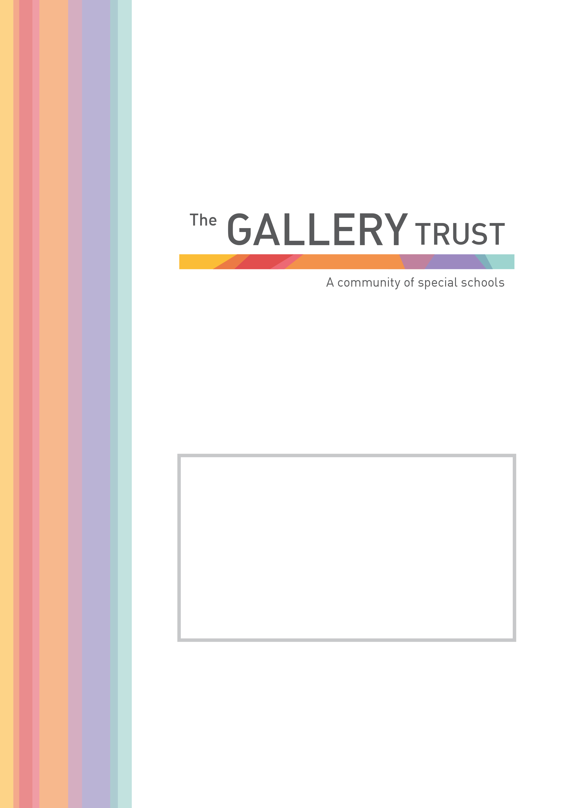
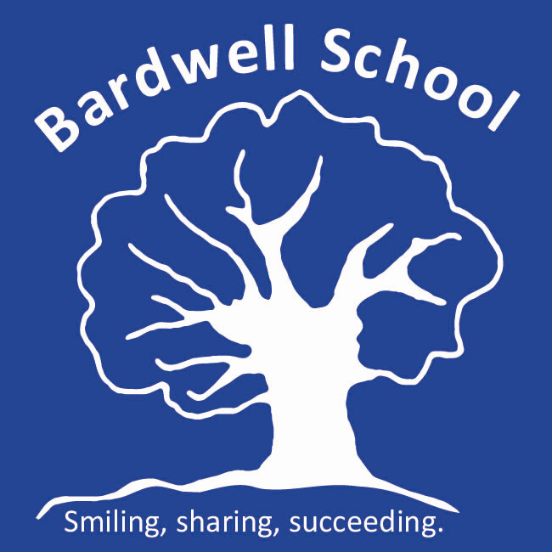
Teaching Assistant
Candidate Information
November 2020

Contents

Welcome from Chair of Trustees

Advertisement

About The Gallery Trust

Job description

Selection criteria

Welcome

Thank you for your interest in the post of Teaching Assistant at Bardwell School.

Bardwell School is a successful school and has grown in recent years with a current number on roll of 90 students.

Bardwell School is a community special school for children aged 2 – 19 with severe learning difficulties and profound and multiple learning difficulties. We are passionate about children at Bardwell having their abilities recognised and celebrated, whilst receiving an excellent education. The whole staff team is committed to very high standards both professionally and in relation to every aspect of our pupils’ education.

The Board of Trustees is seeking an inspirational and dynamic Teaching Assistant: a gifted practitioner who can meet the needs of this vibrant and diverse community.

Bardwell School is a member of The Gallery Trust, an expanding Special School Trust which is dedicated to improving outcomes for SEND learners in Oxfordshire. The Trust has a national reputation for excellence and is influential in the development of SEND strategy in the county. With four academies currently in the Trust, two special academies in pre-opening and with two special schools currently in negotiation to join our MAT, the Trust’s aim is to build a community of special schools.

Please visit our website to find out more about the school, and if you would like to visit the school to find out more about this exceptional opportunity and inform your application, you will be most welcome. Our staff and students will be delighted to meet you!

On behalf of the Board of Trustees, thank you again for your interest and we look forward to hearing from you.

Sian Rodway
Chair of Trustees

Teaching Assistants

Grade 6: £19,945 to £22,021 pro rata per annum
Actual annual salary £14,142 to £15,614 per annum
31.5 hours a week, term time only (38 weeks a year)

To start at the start of January 2021 (or as soon as possible)

Bardwell School is the community special school in Bicester, we serve the Bicester and Kidlington areas, but also have children from across Oxfordshire. We are seeking enthusiastic and motivated staff to join our thriving and vibrant community at an exciting time in our development.
Judged as Good by Ofsted in July 2018, we recognise ourselves as a very strong school, that is on a continuous journey of school improvement. We make respectful relationships with our students through our understanding of their special educational needs, thorough assessment of their skills and abilities and carefully planning next steps for them. We are a warm and caring community, dedicated to equipping pupils with the skills and knowledge they need to succeed.
The role of the Teaching Assistant involves setting appropriate boundaries for children, supporting with their education and care and liaising with families to get the best possible outcomes. You will have the attributes to work across the whole school, including supporting children with complex health and medical needs and students who may demonstrate physically challenging behaviour. You will have, or be willing to quickly develop, a good understanding of our school curriculum, how to create a climate for success and how to support pupils with special educational needs and disabilities to learn and develop. You will also demonstrate a resilient and instinctive approach in meeting our pupils’ needs.

If you share our passion for making a real difference to the lives of children and young people with special needs, this could be the opportunity you are looking for. In return for your contribution to our team, you will work in an environment, which is innovative and in a role which is rewarding and fulfilling. We will provide you with induction and training, and the opportunity to join the Local Government Pension Scheme, one of the largest public sector pension schemes in the UK. This is an exciting time to join our team, having recently joined The Gallery Trust, we are further developing our curriculum and assessments and will soon be having a new hall and classrooms built to support further expansion.
Application process

To apply for this post, please email jobs@bardwell.oxon.sch.uk or telephone 01869 242182 to request an application form and a job pack. You can also download an application form and job pack from our website:
www.bardwell.oxon.sch.uk

Please submit your application form by 5pm on Sunday 15th September 2020 to jobs@bardwell.oxon.sch.uk or by post. Please ensure you detail any gaps in employment, and use the selection criteria which is contained in the job pack when you prepare your application, as shortlisting for interview will be based on how closely you demonstrate your ability to fulfil the essential criteria. We do not accept CVs. If you are shortlisted, we will take up written references before your interview so please provide permission for this and provide accurate phone and email contact details for your referees. One of your referees must be your current or last employer, and if you are employed in a school, must include your current Head Teacher.

Bardwell School is committed to safeguarding and promoting the welfare of all children and expects all staff to share this commitment. The successful candidate will be subject to an Enhanced DBS check, Occupational Health check and a probationary period of 6 months. The Gallery Trust is an equal opportunities employer and we welcome applications from a range of ethnic backgrounds to represent diversity in line with our school community.

About The Gallery Trust

The Gallery Trust is a Multi Academy Trust which is dedicated to improving outcomes for SEND learners in Oxfordshire. Formerly known as The Iffley Academy Trust, the driving force of the Trust is simple: it is to provide outstanding education and support for young people with special needs and disabilities, enabled through:

- Commitment to special education – striving to provide the best specialist learning experience for all students

- Opportunities for all to learn – ensuring that students and staff have access to learning pathways which enhance their lives

- Genuine respect and value – creating relationships which promote trust, confidence and respect within environments which are safe and secure

The Trust currently has three member Academies: Iffley Academy, Bardwell School and Bloxham Grove Academy, a new free special Academy scheduled to open in 2020 in North Oxfordshire. The Trust is currently in formal negotiation with two special schools who are keen to join the Trust, and a further three special schools in the county have expressed interest in becoming part of The Gallery Trust. The Trust’s vision is to build an organisation over the next ten years which includes converter academies, free schools and sponsored academies, and which will meet the needs of all cohorts of SEND students in the county. All constituent academies will have the opportunity to share expertise across the Trust and work with peers who are specialists in SEND, sharing common aims and goals.

The Trust is committed to investment in learning, developing leadership, working in partnership and through a shared vision, enabling all students to reach their full potential.

JOB DESCRIPTION

Teaching Assistant

Job Purpose:

To assist and support the Head Teacher and teaching staff in providing high standards of teaching and learning across the curriculum and to promote the school’s vision and ethos.

Introduction:

This job description describes in general terms the normal duties which the postholder will be expected to undertake. However, the job or duties described may vary or be amended from time to time without changing the level of responsibility associated with the post. The performance of all duties and responsibilities shown below will be under the reasonable direction of the Head Teacher. The Head will be mindful of her/his duty to ensure that the employee has a reasonable workload and sufficient support to carry out the duties of the post. This job description will be reviewed at least annually and any changes will be subject to consultation. The academy’s grievance procedure will be used to resolve any disagreement arising out of the job description.

The job description involves:

- To understand our school vision, aims and ethos and promote these at all times
- To work under the direction of the class teacher to support teaching and learning in our classes as timetabled (this will include small group and one-to-one sessions)
- To produce/reproduce materials and resources to support teaching and learning
- To positively support pupils in informal sessions such as break-times and lunch-times
- To support pupils with personal care needs
- To support with a child’s individual needs, following specific training and advice (for example movement and positioning programmes, managing epilepsy, managing challenging behaviour, supporting with eating and swallowing skills)
- To be a role-model for our pupils
- To work within our ethos to positively manage behaviour, recognising that praise and reward are the most effective behaviour management tools
- To support with the physical management of challenging behaviour. This role will involve the restrictive physical interventions, including with young adults.
- To support pupils in inclusion sessions as required
- To participate in off-site learning activities
- To support pupils with swimming and hydrotherapy
- To feedback back pupil progress to the class teacher and contribute ideas for targets and planning
- To attend weekly team meetings
- To attend whole staff meetings once a month
- To be committed to your own professional develop and participate in professional development systems and activities as required
- To follow school and county guidelines for safe working practice to safeguard pupils and staff in schools, maintaining confidentiality and attending training as required. Including:
- Reading and understanding Keeping Children Safe in Education (Part 1)
- Following our Code of Conduct (see staff handbook)
- Knowing and following our Child Protection/ Safeguarding Policy and procedures
- Following procedures within our Whistleblowing Policy as appropriate.
- To be aware of and comply with Health and Safety legislation and policies of the school including;
- Sign out and in at reception (when leaving the site)
- Cooperate with health and safety requirements.
- Report all defects on the maintenance forms and return them to the office.
- Complete and action risk assessments for all potentially hazardous on/off site activities.
- Use, but not misuse things provided for your health, safety and welfare.
- Assess the risk - do not undertake unsafe acts.
- Inform Head of Establishment of any “Near-Misses”.
- Be familiar with the emergency action plans for fire, first aid, bomb, security and off site issues.
- Raise health, and safety and environmental issues with pupils.
- To promote the school and our pupils
- Any other class duties as directed by Headteacher, Assistant Headteachers or class teacher

SELECTION CRITERIA

Teaching Assistant

Essential:

- Level 2 (GCSE or equivalent) in mathematics and English, or suitable equivalent experience
- Understanding of child development and learning
- Ability to relate well to children and adults
- Ability to self-evaluate learning needs and actively seek learning opportunities
- Ability to work flexibly, throughout the whole school, meeting the needs of pupils in a range of contexts
- Good organisational and interpersonal skills
- Willingness and ability to undertake physical management of pupils, following appropriate training
- Willingness to undertake First Aid training and to attend to the medical, first aid and personal needs of pupils.
- Ability to take an active role in the support of PE lessons
- Effective use of ICT to support learning

Desirable:

- Experience of working with or caring for children of relevant age
- Team Teach trained
- NVQ 2 for Teaching Assistants or equivalent qualifications or experience
- First aid trained
- Understanding of relevant policies/codes of practice and awareness of relevant legislation
- General understanding of National Curriculum
- Full driving license

